SEVEN SEAS WORKFORCE SOLUTIONS Bridging Borders, Building Futures

COMPANY PROFILE

1. About Us
Seven Seas Workforce Solutions Middle East is a leading ISO 9001:2005 certified global manpower recruitment consultancy based in Pakistan, serving clients across the Middle East and international markets. With over 18 years of experience in the recruitment industry, we specialize in providing skilled, semi-skilled, and unskilled workforce solutions tailored to the requirements of employers in the GCC and MENA regions.
We connect global employers with verified, experienced, and job-ready talent through smooth, ethical, and compliant recruitment processes. Our mission is to bridge the gap between demand and supply of quality human capital by delivering efficient and trustworthy workforce solutions.

2. Vision
To become a globally trusted bridge between talent and opportunity, connecting skilled professionals across continents while empowering businesses with reliable, ethical, and future-ready workforce solutions.
We envision a world where borders do not limit potential and where every individual has access to meaningful international career opportunities.

3. Mission
At Seven Seas Workforce Solutions, our mission is to deliver seamless, ethical, and efficient overseas manpower recruitment services that meet the evolving demands of global industries.
We are committed to:
- Identifying, nurturing, and deploying top-tier global talent
- Building long-term partnerships based on trust, quality, and performance
- Ensuring transparent, compliant, and ethical recruitment practices
- Supporting candidates from selection to successful overseas placement
- Continuously adapting to global workforce trends with innovation

4. Core Values
1. Integrity Beyond Borders – Ethical and transparent practices across all operations
2. Global Excellence – Delivering international-standard recruitment solutions
3. People-Centric Approach – Prioritizing dignity, growth, and welfare of candidates and clients
4. Reliability & Trust – Consistent and dependable recruitment services
5. Cultural Connectivity – Bridging global workforce diversity
6. Innovation in Recruitment – Modern, data-driven hiring solutions
7. Compliance & Responsibility – Strict adherence to international labour laws

5. CEO Message
Since arriving in the United Arab Emirates in 2002, I have had the privilege of serving and contributing to the growth of various industries across the UAE and GCC region. Over the years, this journey has provided valuable experience, strong industry relationships, and a deep understanding of workforce requirements in an evolving global market.
At Seven Seas Workforce Solutions, our vision is to connect skilled talent with meaningful international opportunities while supporting organizations with reliable, efficient, and ethical workforce solutions.
We are committed to delivering recruitment and workforce services built on trust, professionalism, compliance, and long-term partnerships. Every client we serve and every professional we deploy reflects our dedication to quality and operational excellence.
As we continue to grow, our focus remains on providing world-class workforce solutions that support business success, strengthen global connections, and contribute to the future of international employment.

Naeem Shahzad
Chief Executive Officer
Seven Seas Workforce Solutions


6. Our Expertise
We support businesses of all sizes—from start-ups to large enterprises—by delivering fast, reliable, and cost-effective recruitment solutions.
We specialize in:
- Bulk and urgent manpower supply
- Skill-based recruitment matching
- Industry-specific workforce deployment
- International staffing across GCC and global markets
Our recruitment network spans Pakistan, India, Nepal, Bangladesh, and other manpower-rich regions.

7. Global Reach
We proudly serve clients across:
UAE | Saudi Arabia | Qatar | Oman | Kuwait | Bahrain
Our strong international recruitment network ensures access to a diverse, skilled, and industry-ready workforce.

8. Verification & Trust Assurance
We ensure complete transparency and reliability through professional verification systems:
- Employment verification
- Educational credential verification
- Background checks and reference validation
This guarantees that all candidates are fully screened and job-ready.

9. Core Services

SERVICES

1. Overseas Recruitment

Hero Title
Overseas Recruitment Services

Hero Subtitle
Delivering reliable, skilled, and qualified manpower solutions to businesses across the UAE, GCC, and international markets.

Introduction
Seven Seas Workforce Solutions specializes in providing comprehensive overseas recruitment solutions for organizations seeking skilled, semi-skilled, technical, and professional manpower across multiple industries.
With a strong recruitment network, industry expertise, and efficient hiring processes, we support businesses with quality workforce sourcing, screening, selection, and deployment services tailored to their operational requirements.
We are committed to delivering dependable manpower solutions that help businesses achieve operational efficiency, project success, and workforce stability.

Our Recruitment Solutions
- Skilled manpower recruitment
- Semi-skilled workforce recruitment
- Professional and white-collar hiring
- Technical staffing solutions
- Bulk hiring and mass recruitment
- Project-based recruitment
- Permanent staffing solutions
- International recruitment support
- Fast-track mobilization support

Why Choose Us
- Extensive candidate database
- Fast and efficient recruitment process
- Industry-specific hiring expertise
- Skilled trade screening and evaluation
- GCC market understanding
- Compliance-focused recruitment practices
- Timely mobilization and deployment support

Call To Action
Partner with Seven Seas Workforce Solutions to access dependable overseas recruitment services tailored to your business needs.

2. Workforce Outsourcing

Hero Title
Workforce Outsourcing Solutions

Hero Subtitle
Flexible workforce outsourcing solutions designed to help businesses manage manpower efficiently while reducing operational complexity.

Introduction
Seven Seas Workforce Solutions provides comprehensive workforce outsourcing services that enable organizations to focus on their core operations while we manage workforce deployment, coordination, and administration.
Our outsourcing solutions are designed to support businesses requiring temporary, project-based, long-term, or contract workforce solutions across multiple industries.
We deliver scalable workforce support tailored to project demands, operational requirements, and workforce planning strategies.

Our Outsourcing Services
- Workforce outsourcing
- Labor outsourcing
- Contract staffing
- Temporary staffing solutions
- Long-term manpower deployment
- Project workforce management
- Technical workforce outsourcing

Key Benefits
- Reduced recruitment and HR overhead
- Flexible workforce scalability
- Faster workforce deployment
- Improved operational efficiency
- Streamlined workforce management
- Reliable manpower availability

Why Choose Us
- Reliable workforce supply capabilities
- Strong operational coordination
- Industry-focused outsourcing solutions
- Efficient manpower management systems
- Commitment to workforce quality and compliance

Call To Action
Enhance operational efficiency with flexible workforce outsourcing solutions from Seven Seas Workforce Solutions.

3. Executive Search

Hero Title
Executive Search Services

Hero Subtitle
Professional executive search and talent acquisition solutions for organizations seeking experienced leadership and specialized professionals.

Introduction
Seven Seas Workforce Solutions provides strategic executive search solutions designed to help organizations identify, attract, and recruit highly qualified leadership professionals and industry specialists.
Our executive search approach focuses on understanding organizational goals, technical requirements, and leadership expectations to deliver exceptional talent solutions.
We support businesses in sourcing experienced professionals across technical, operational, engineering, and management roles.

Our Executive Search Solutions
- Leadership hiring
- Executive recruitment
- Senior management hiring
- Technical specialist recruitment
- Industry-specific headhunting
- Confidential recruitment assignments
- Professional talent sourcing
- Global talent acquisition

Why Choose Us
- Targeted talent sourcing strategies
- Access to experienced professionals
- Industry-specific recruitment expertise
- Confidential and professional process
- Client-focused recruitment approach

Call To Action
Find exceptional leadership talent with professional executive search solutions tailored to your business objectives.

4. HR Solutions

Hero Title
HR Solutions

Hero Subtitle
Integrated HR solutions designed to support workforce management, talent acquisition, employee administration, and organizational growth.

Introduction
Seven Seas Workforce Solutions offers comprehensive HR support services that help businesses streamline workforce operations, improve efficiency, and enhance talent management processes.
Our HR solutions are tailored to meet the evolving workforce needs of modern organizations across multiple industries.
We support companies with scalable HR services that improve operational productivity while reducing administrative burden.

Our HR Services
- HR consulting
- Talent acquisition support
- Recruitment process outsourcing (RPO)
- Workforce planning
- Employee onboarding support
- HR documentation support

Benefits of Our HR Solutions
- Improved workforce efficiency
- Reduced administrative workload
- Streamlined HR operations
- Better workforce planning
- Scalable HR support services

Why Choose Us
- Experienced HR support team
- Professional workforce management
- Compliance-focused processes
- Industry-specific expertise

Call To Action
Optimize your workforce operations with professional HR solutions designed for modern business needs.

5. Trade Testing

Hero Title
Trade Testing & Skill Evaluation

Hero Subtitle
Comprehensive trade testing and skill evaluation services to ensure workforce competency, technical expertise, and project readiness.

Introduction
Seven Seas Workforce Solutions provides professional trade testing and technical skill assessment services to evaluate candidate competency before deployment.
Our testing procedures help employers select qualified personnel with the required technical skills, practical knowledge, and operational capabilities for specific project requirements.
We focus on workforce quality assurance through structured trade evaluations and technical competency assessments.

Our Trade Testing Services
- Welding trade testing
- Electrical skill testing
- Plumbing assessments
- HVAC trade evaluations
- Construction skill assessments
- Equipment operator testing
- Mechanical trade testing
- Technical competency evaluation
- Practical skill verification

Benefits
- Improved workforce quality
- Reduced hiring risks
- Better project performance
- Verified technical competency
- Enhanced client confidence

Why Choose Us
- Structured trade assessment procedures
- Industry-standard evaluation methods
- Skilled technical assessment support
- Reliable candidate screening process

Call To Action
Ensure workforce quality and technical competency with professional trade testing solutions.

6. Mobilization Services

Hero Title
Mobilization Services

Hero Subtitle
Efficient mobilization and deployment support services ensuring smooth workforce movement, documentation coordination, and timely deployment.

Introduction
Seven Seas Workforce Solutions offers end-to-end mobilization support services to facilitate seamless workforce deployment for international projects and business operations.
We coordinate documentation, travel arrangements, processing requirements, and deployment logistics to ensure smooth mobilization of candidates.
Our mobilization services are designed to reduce delays, improve operational readiness, and simplify workforce deployment processes.

Our Mobilization Services
- Candidate mobilization coordination
- Visa processing support
- Medical coordination
- Embassy documentation support
- Air ticket coordination
- Travel arrangement support
- Pre-departure orientation
- Deployment logistics support
- Joining coordination

Benefits
- Faster deployment process
- Reduced administrative delays
- Streamlined documentation management
- Efficient workforce movement
- Improved project readiness

Why Choose Us
- Strong mobilization coordination
- Efficient documentation support
- Reliable deployment management
- GCC workforce deployment expertise

Call To Action
Simplify workforce deployment with reliable mobilization and coordination services from Seven Seas Workforce Solutions.

7. Visa & Immigration Services

Hero Title
Visa & Immigration Services

Hero Subtitle
Professional visa and immigration support services for individuals, professionals, business travelers, and workforce deployment across the UAE and GCC region.

Introduction
Seven Seas Workforce Solutions provides reliable visa and immigration support services designed to simplify international travel, workforce deployment, and business mobility.
We assist individuals and corporate clients with visa coordination, documentation guidance, and immigration support across the UAE and GCC countries.
Our experienced team ensures efficient processing support and reliable assistance throughout the visa application and travel coordination process.

Our Visa Services
- UAE tourist visa assistance
- UAE visit visa support
- GCC visa assistance
- Business visa support
- Employment visa coordination
- Family visa assistance
- Immigration documentation guidance
- Travel coordination support

Corporate Support Services
- Workforce visa coordination
- Business travel support
- Employee deployment assistance
- Corporate immigration coordination

Why Choose Us
- Professional visa support process
- Timely documentation coordination
- Reliable client assistance
- GCC immigration support expertise
- Efficient application handling

Call To Action
Experience smooth and hassle-free visa and immigration support services tailored to your travel and workforce requirements.

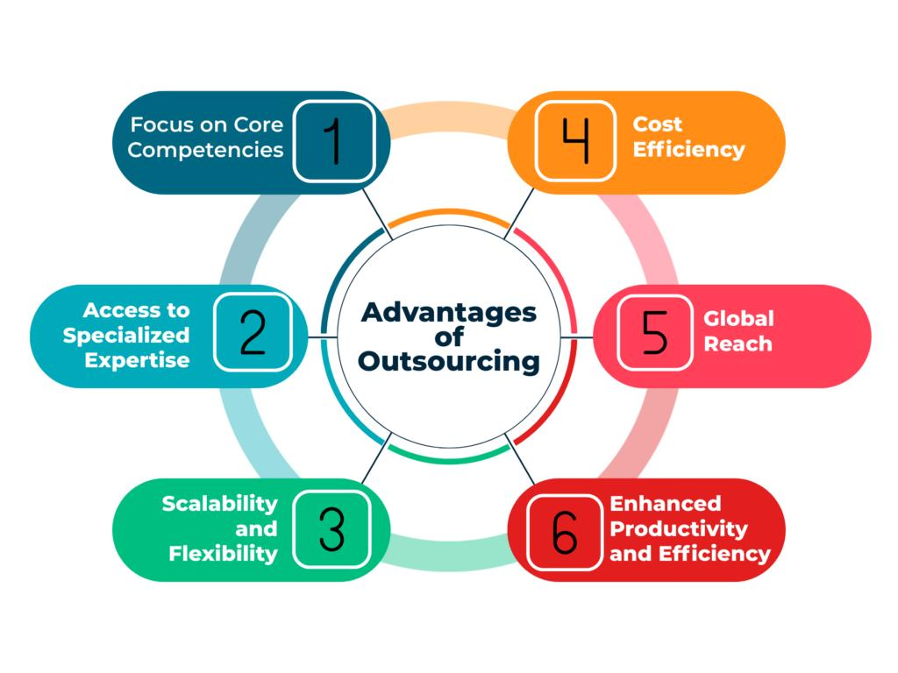

13. Contact Information
Naeem Shahzad
Overseas Recruitment Manager
Seven Seas Workforce Solutions
🌐 www.sevenseas-me.com
📧 naeem@sevenseas-me.com
📧 info@sevenseas-me.com
📱 Pakistan: +92 321 4306989
📱 UAE: +971 55 9292319

14. Closing Statement
If you are seeking skilled, semi-skilled, or unskilled manpower from Pakistan, India, Nepal, Bangladesh, Sri Lanka, Philippines, and other regions, we are ready to provide fast, reliable, and professional recruitment solutions tailored to your needs.

Suggested Website CTA Banner

Main Heading
Your Trusted Global Workforce Solutions Partner

Description
Seven Seas Workforce Solutions delivers reliable recruitment, outsourcing, HR, mobilization, and immigration services tailored to businesses across the UAE, GCC, and international markets.

CTA Buttons
- Contact Us
- Request Manpower
- Get Consultation

Suggested Footer Tagline
Delivering reliable workforce, recruitment, outsourcing, and mobility solutions for businesses across the UAE, GCC, and international markets.

Suggested SEO Keywords
- Overseas Recruitment Company
- Workforce Outsourcing Solutions
- Manpower Supply Company
- GCC Recruitment Agency
- UAE Recruitment Services
- Executive Search Firm
- HR Solutions Company
- Trade Testing Services
- Visa & Immigration Services
- Workforce Mobilization Services
- Pakistan Overseas Recruitment Agency

